**Project Documentation**

* Title of the Project: - College Management System
* Batch No: - 170
* Student Details (name + registration number): -

N. Amandi Yalapola _E120237

* Lecture Name: - Mr. Pubudu

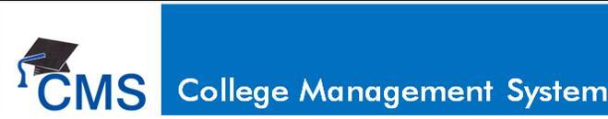

# ACKNOWLEDGEMENT

There are many people who have helped us directly or indirectly in the successful completion of our project. We would like to take this opportunity to thank one and all.

It is my sincere obligation to thank **Mr.Amila**, Head of Information Technology Department, , who has extended positive support and precious suggestions to make the project work a success.

I am very thankful to our project guide **Mr.Pubudu** who has been inspiring guide and committed caretaker for his unflinching devotion. The encouragement and support by him, especially in carrying out this project motivated me to complete this project.

I would like to express deep sense of gratitude to our staff members of Dept. of Information Technology for their co-operation, which has given in the congruency to build up this project.

I would like to thank all our friends for their help and constructive criticism during my project period. Finally, I am very much indebted to my parents for their moral support and encouragement to achieve goals. I have no words to express my gratitude and still I am very thankful to my parents who have shown me this world and for every support they gave me.

**Table of Contents**

Abstract 4

Chapter 1 – Introduction 6

1.1 Objective 6

1.2 Scope 6

Chapter 2 – Analysis 8

2.1 Problems of the Current Manual System 8

2.2 The Functions of the New System. 9

2.3 Software Development Methodology(Waterfall) 9

2.3.1 The Waterfall Model: 9

2.3.2 Diagram: 10

2.3.3 Reason the waterfall model in the software development cycle: 11

2.3.4 Advantages of the waterfall model: 11

2.3.5 Disadvantages of the waterfall model: 11

Chapter 3 – Design 12

3.1 Flow Charts 12

3.1.1 Add: - 12

3.1.2 Search: - 13

3.1.3 Update: - 14

3.1.5 Logout the System: - 16

3.2 Use Case Diagrams 17

3.3 Class Diagrams for the Proposed System 18

Chapter 4 – Implementation 19

4.1 User Interfaces and Codes 19

4.2 Database & Table data 42

Chapter 5 – Evaluation 45

5.1 Testing Techniques 45

Conclusion: 51

References 52

# Abstract

Now a day’s education plays a great role in development of any country. Many of education organizations try to increase education quality. One of the aspects of this improvement is managing of school resources. In case of manual system, they need a lot of time, manpower etc. Here almost all work is computerized. So the accuracy is maintained. College Management System mainly deals with Employee Profile, Payroll Management and Fee collection which can be managed by the Admin. Computerized college management system is developed to facilitate the general administration system to manage the various information of student and employees involved in college. So, that college can access accurate information quickly and easily as and when required, thereby improving its operational efficiency and effectiveness.

This project is aimed at developing an Online Intranet College Management System (CMS) that is of importance to either an educational institution or a college. The system (CMS) is an Intranet based application that can be accessed throughout the institution or a specified department. This system can be used as an attendance monitoring system for the college. Students/staffs logging in may also access/search any information. Attendance and marks will be updated by staff. This system (C.M.S) is being developed for programming college to maintain and facilitate easy access to information. For this the users need to be registered with the system after which they can access or modify data as per the permissions given to them. EMS is a system that will provide you a bird’s eye view of the functioning of the entire educational institution. It is a management information system helps to manage the different processes in an educational institution like, Staff Management, Academics, Student Management, and Accounts etc. The information is made using the latest technologies and helps to make decision making a lot faster, effective and easier than ever before. Also helps to improve the overall quality of education of the institution.

CMS is an intranet-based application that aims at providing information to all the levels of management with in an organization. This system can be used as a knowledge/information management system for the college. For a given student/staff (technical/non-technical) can access the system to either upload or download some information from the database. We use database and database technology are having a major impact on the growing use of computers. The implementation of the system was done using c# and SQL Server 2012 technologies, allowing system to be run in Windows OS. In a nutshell, Education Management Software managed your education institution by simplifying and automating processes and addressing the needs of all stakeholders helping them to be more efficient in their respective roles.



# Chapter 1 – Introduction

## 1.1 Objective

This is a web-oriented application allows us to access the whole information about the college, staffs, students, facilities etc. This application provides a virtual tour of Campus. Here we will get the latest information about the students and staffs. This generic application designed for assisting the students of an institute regarding information on the courses, subjects, , Events, and timetable. It also provides support that a faculty can also check about his daily schedule, can upload assignments, and notices to the students. Here administrator will manage the accounts of the student and, makes the timetable, and upload the latest information about the campus.

## 1.2 Scope

* College information: Through this service one can access the complete information about the college campus such as courses available, admission procedure, placements, college events, achievements etc.
* Student tracking: Any company or any organization that want to check the summary about the student of the college, so that they will be able to choose the particular students for their campus placement And for that purpose they will be given a particular link through which they can access the information required.
* Exam Notification: This facility notifies students and parents about examination schedule.
* Events: It will give information about different events that will be conducted by college time to time. Information about these events will be updated by administrator.
* Online assignments: This service provides the facility to faculty to upload assignments and to students to submit these assignments online.
* Information about staff: It will help in maintaining complete information about college faculty members such as their department, cadre, date of joining, salary, etc. Administrator will register new faculties and remove their account when they leave the college.
* Access/ Search information.
* Login to the system through the first page of the application.
* View/change his/her details.
* Students can give feedback on college/staff/any other student.
* An admin login should be present who can read as well as remove any uploads.

# Chapter 2 – Analysis

## 2.1 Problems of the Current Manual System

Today all works at the time of the admission of the students is done manually by ink and paper, which is very slow and consuming much efforts and time. It is required to design of the computerized **College Management system,** to speed up and make it easy to use system.

The present system is the manual one. Hence all the information about the student and faculty details maintained in the files. The whole session attendance is stored in the registers and at the end of the session the report are generated. It becomes very difficult to generate the report in the middle of the session or as per requirement because it takes more time in calculation. At the end of the session the student who don’t have 75% attendance are get a notice. It is unfair to those students if they would have short attendance so that they could take regular classes.

The ‘**College Management System**’ software overcomes this problem since the data is stored in computer using DBMS, we can retrieve the record of any student whenever we requires it. It also reduces the manpower needed to perform the entire admission and administration task by reducing the paper works needed.

## 2.2 The Functions of the New System.

The functional requirements of this system are:

* Register new students.
* Record the attendance of students.
* Record the feed details of students.
* Register a new teacher/employee.
* Register a new user for the system.
* Record the fees details of students.
* Record the course details and subject information.
* Generate various reports for all transactions in the system.
* Record of the semester updates.
* Record events of the college.
* College Details.

## 2.3 Software Development Methodology(Waterfall)

The Process Model used in our projects **“College Management System”** is **waterfall model**.

### 2.3.1 The Waterfall Model:

The waterfall model is a sequential design process, used in software development processes, in which progress is seen as flowing steadily downwards (like a waterfall) through the phases of Conception, Initiation, Analysis, Design, Construction, Testing, Production/Implementation and Maintenance.

The waterfall development model originates in the manufacturing and construction industries: highly structured physical environments in which after-the-fact changes are prohibitively costly, if not impossible. Since no formal software development methodologies existed at the time, this hardware-oriented model was simply adapted for software development.

### 2.3.2 Diagram:

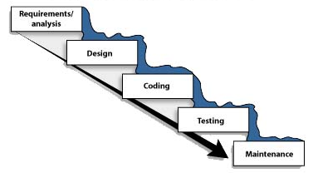

### 

### 2.3.3 Reason the waterfall model in the software development cycle:

* Since we have well known, clean and fixed requirements therefore it best suits for our software development.
* Our product definitions is stable.
* Technology is clearly understood.
* The project is short.

### 2.3.4 Advantages of the waterfall model:

* This model is simple and easy to understand and use.
* In, this model phases are processed and completed one at a time and phases do not overlap.
* Waterfall model works well for smaller projects where sequence are very well understood.

### 2.3.5 Disadvantages of the waterfall model:

* Once an application is in the testing stage, it is very difficult to go back and change something that was not well throughout in the concept stage.
* High amount of the risk and uncertainty.
* Poor model for long and ongoing projects.

# Chapter 3 – Design

## 3.1 Flow Charts

### 3.1.1 Add: -

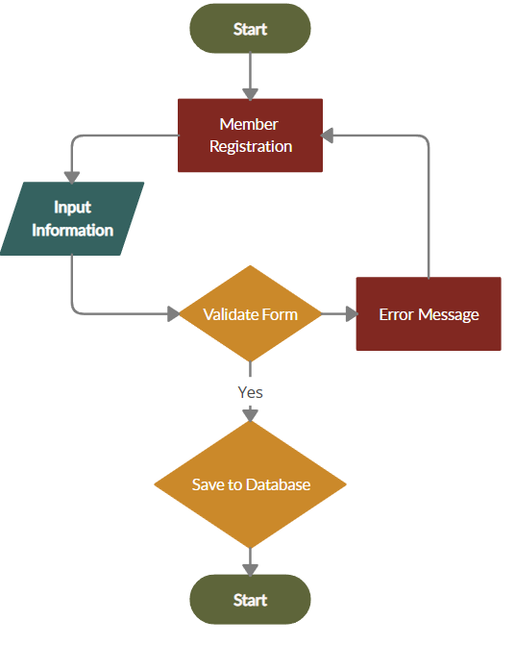

End



### 3.1.2 Search: -

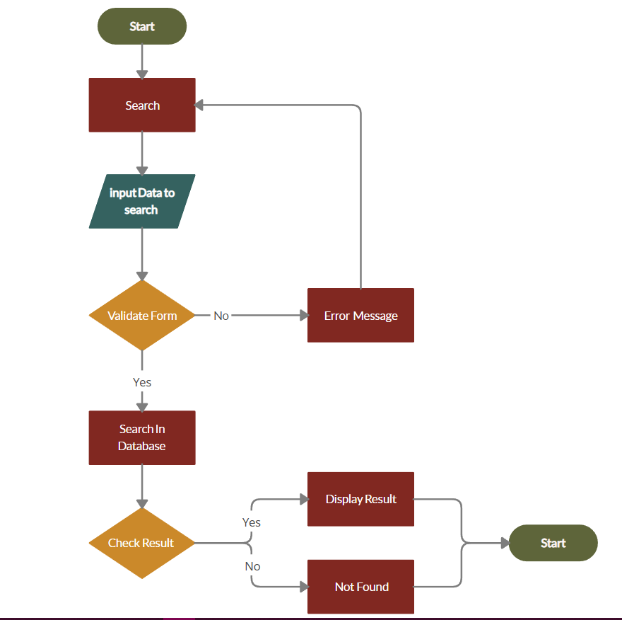

End



### 3.1.3 Update: -

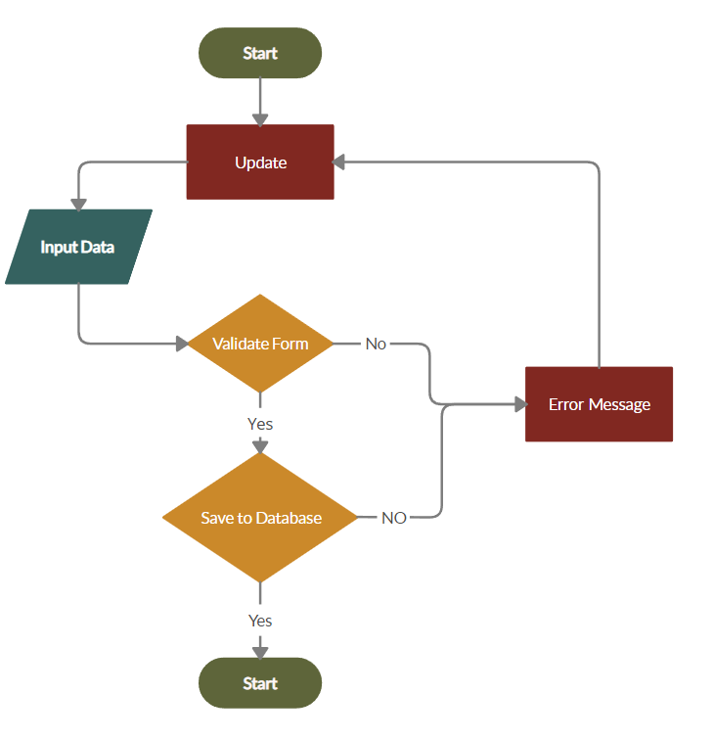3.1.4 Delete: -

End



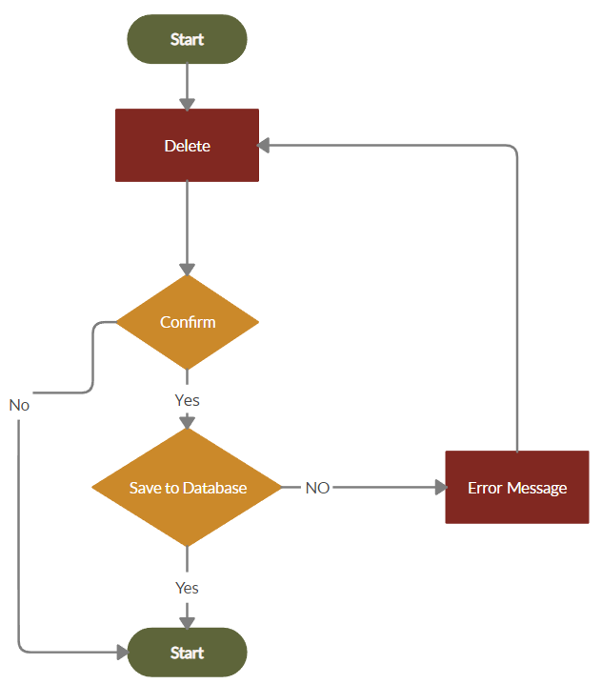

End



### 3.1.5 Logout the System: -

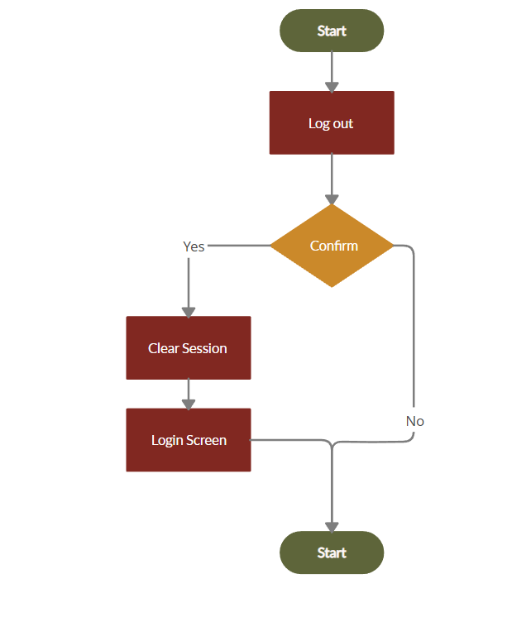

End



## 3.2 Use Case Diagrams

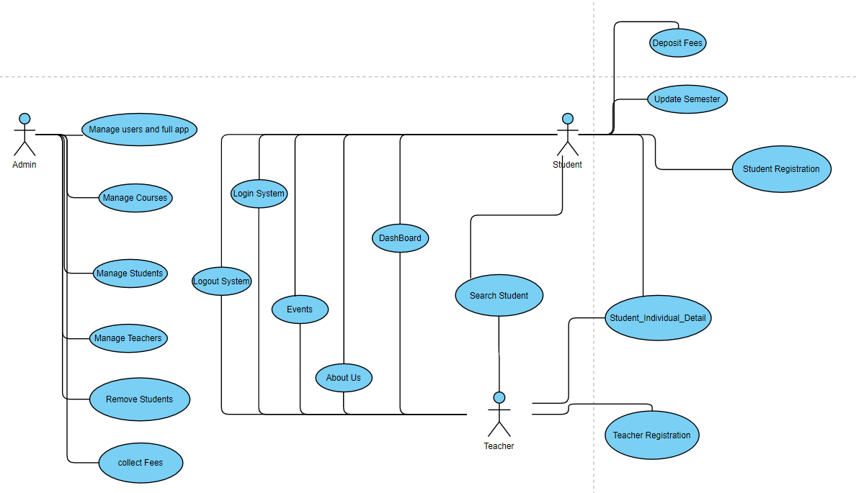

## 3.3 Class Diagrams for the Proposed System

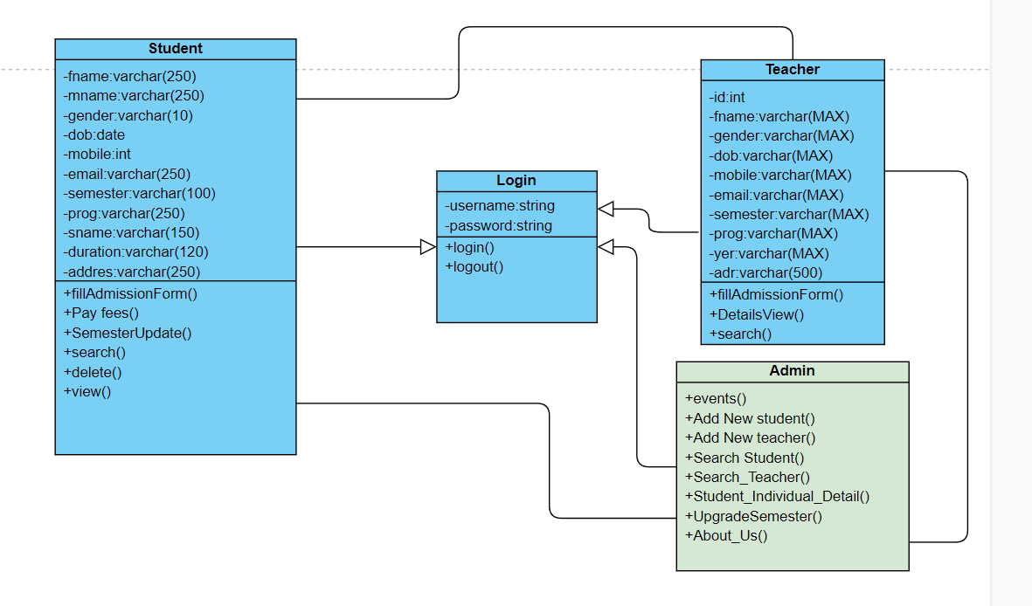

# Chapter 4 – Implementation

## 4.1 User Interfaces and Codes

**Start: -**

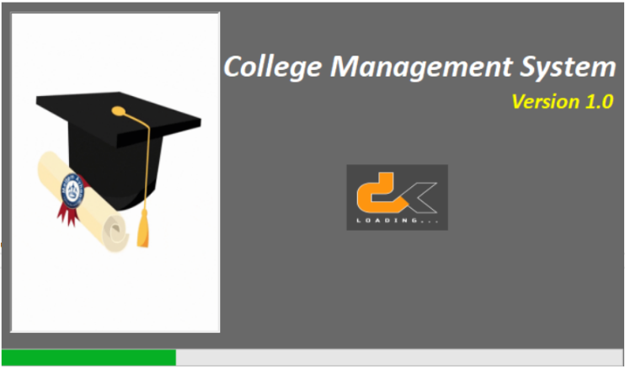

**Code:**

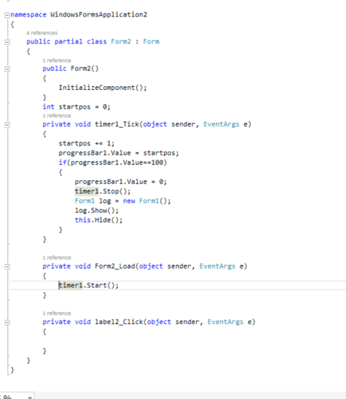

**Login: -**

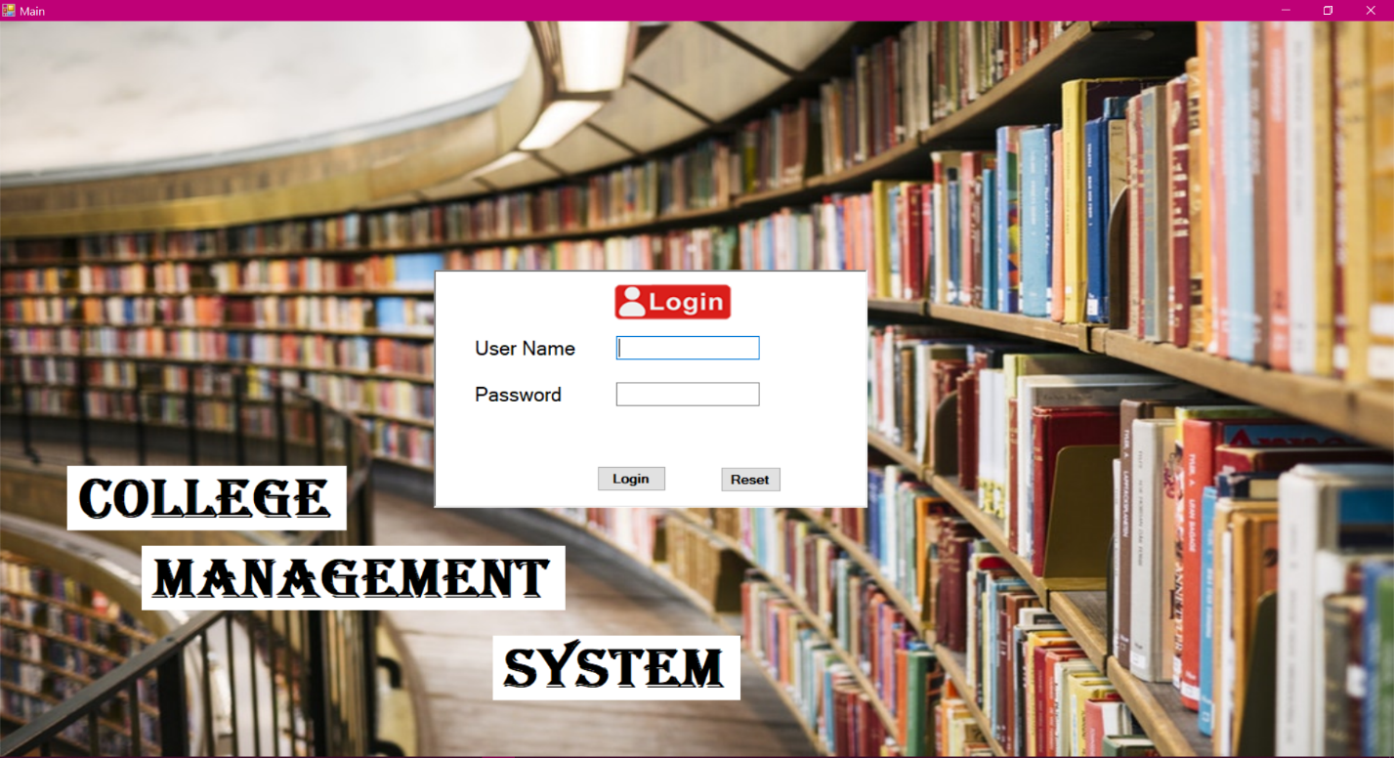

**Code: -**

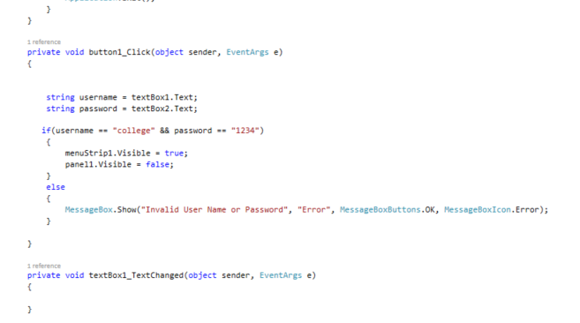

**Main: -**

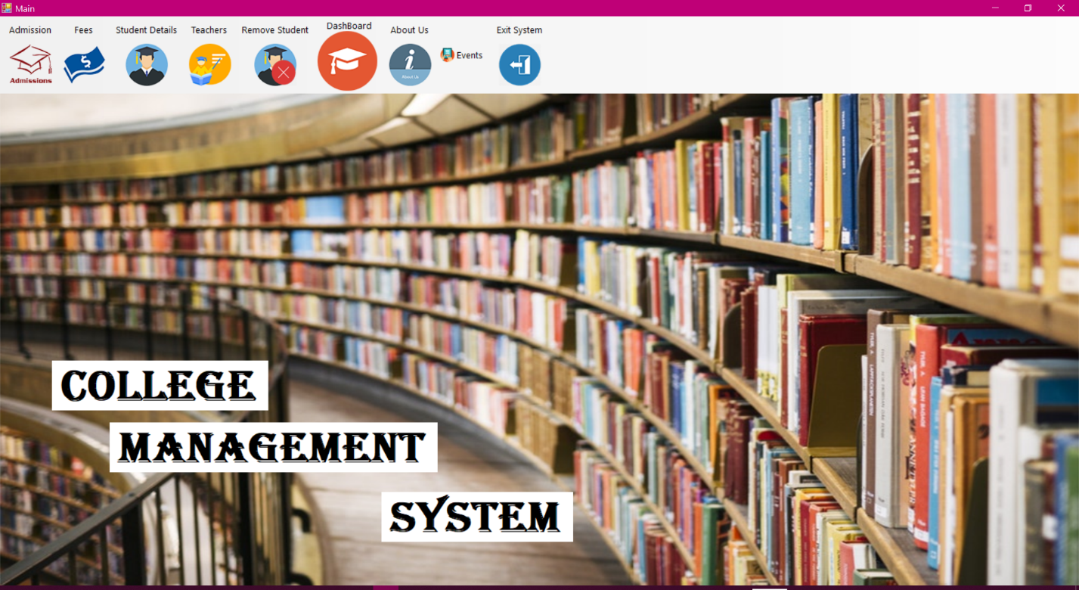

**Code: -**

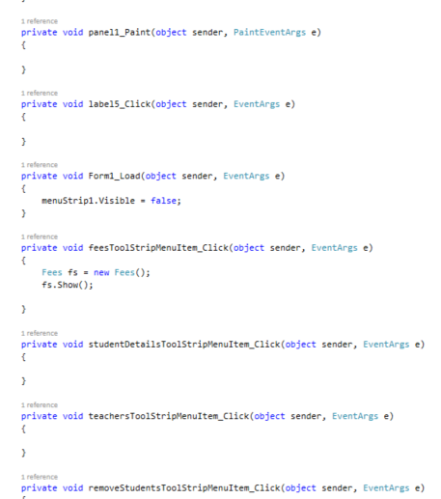

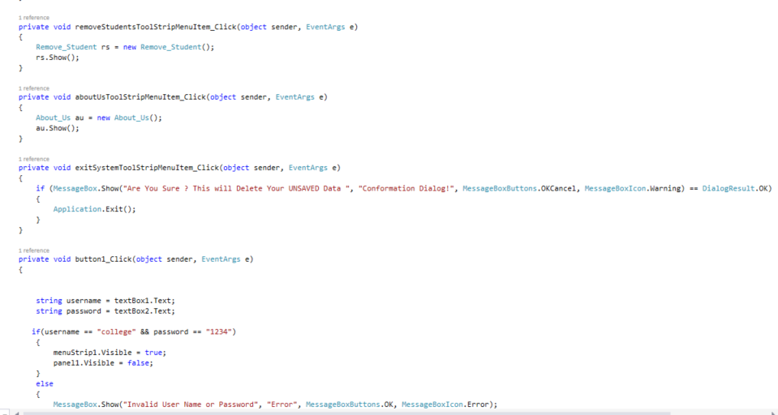

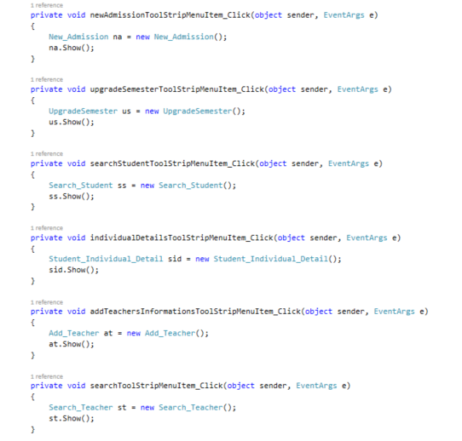

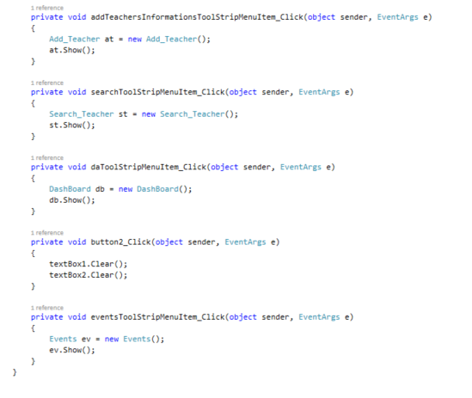

**StudentAdmission: -**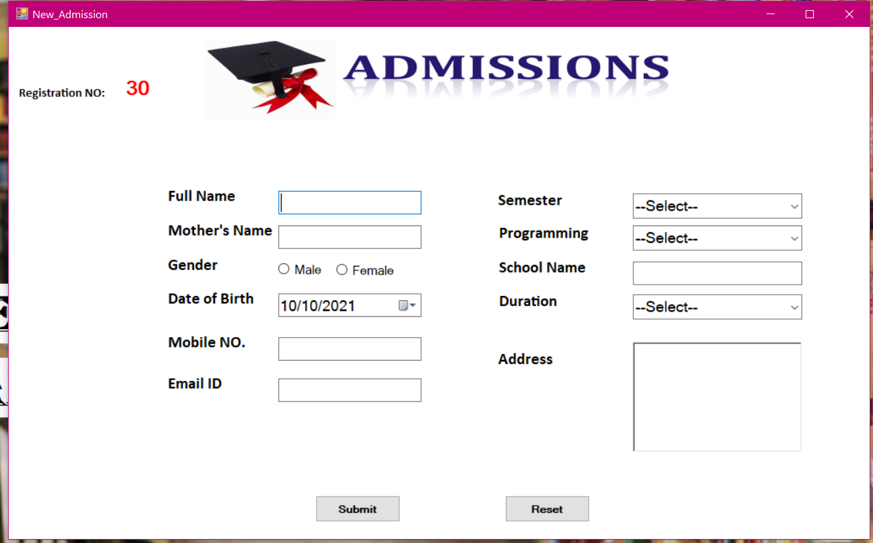

**Code: -**

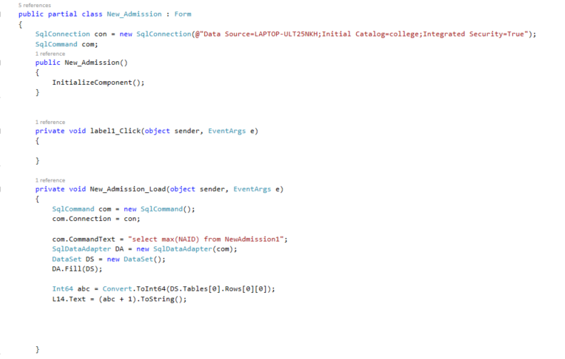

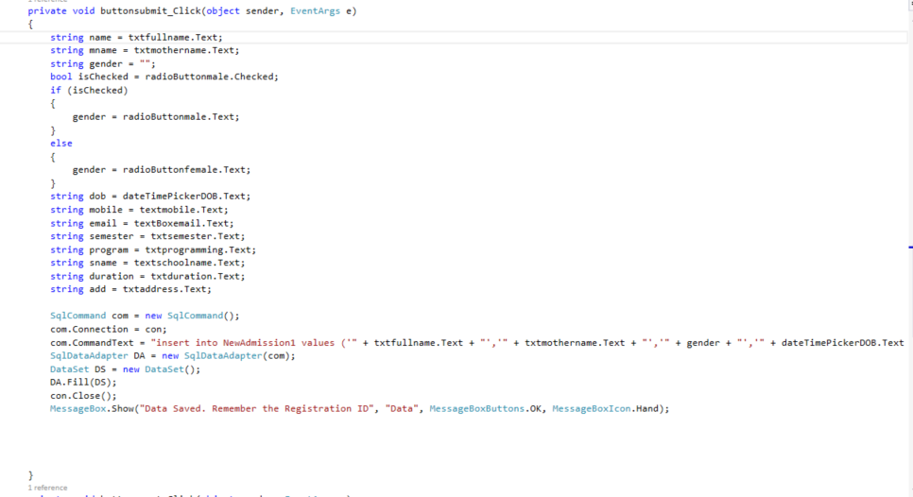

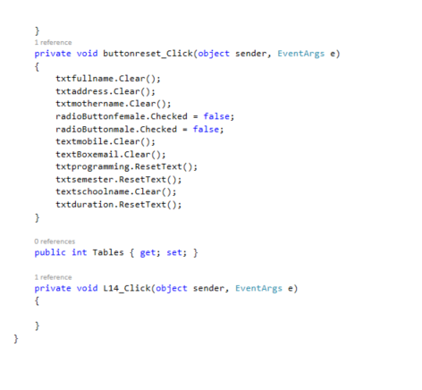

**Upgrade semester: -**

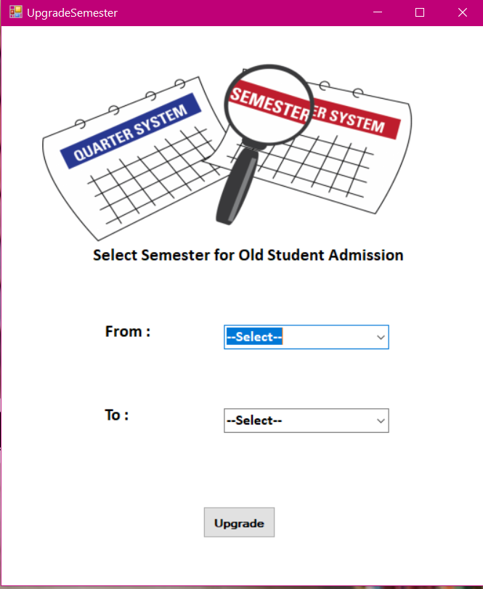

**Code: -**

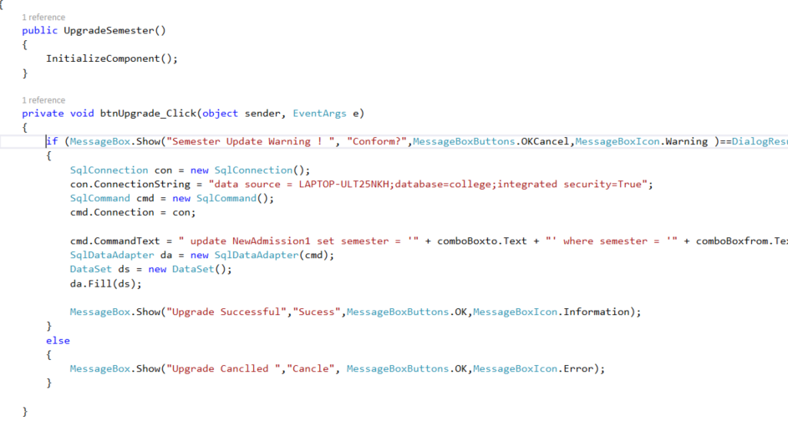

**Fees : -**

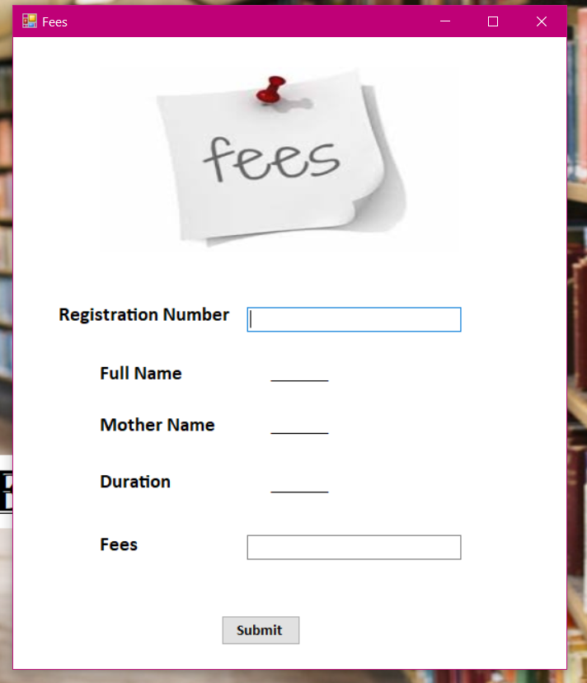

**Code: -**

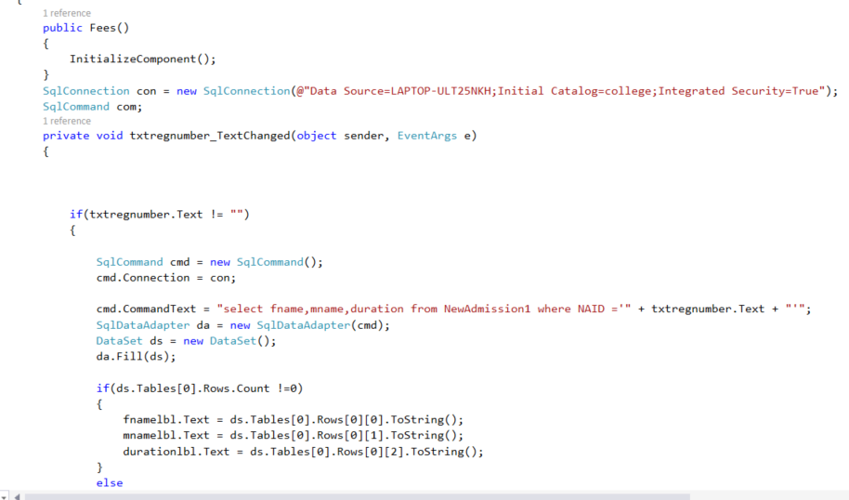

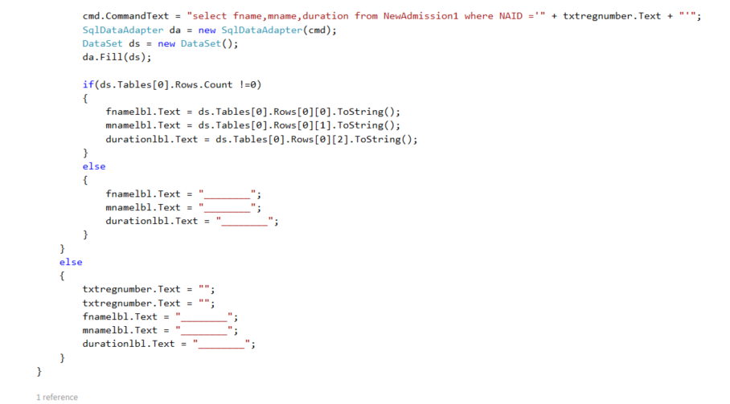

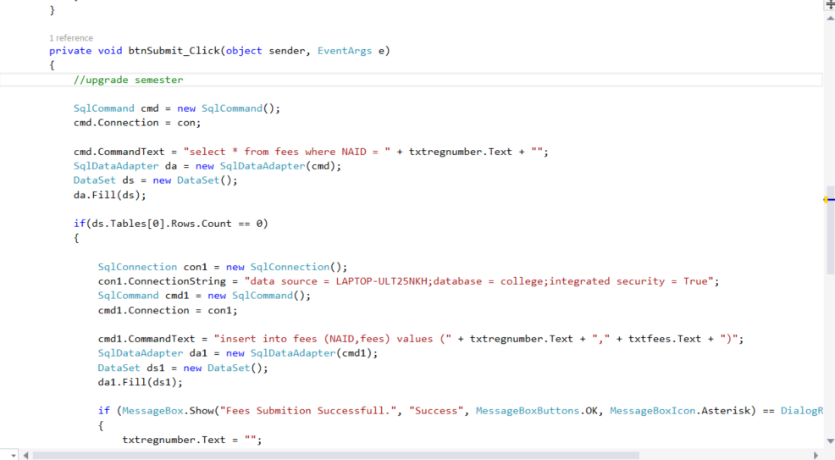

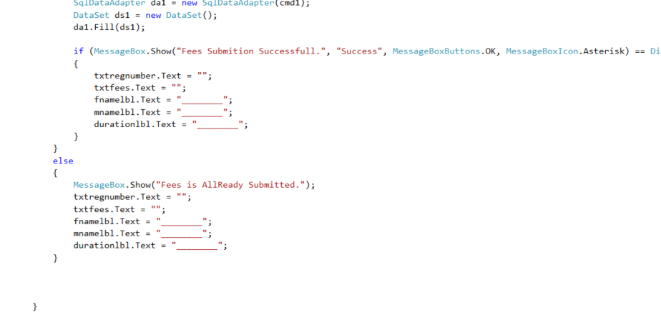

**Search Student: -**

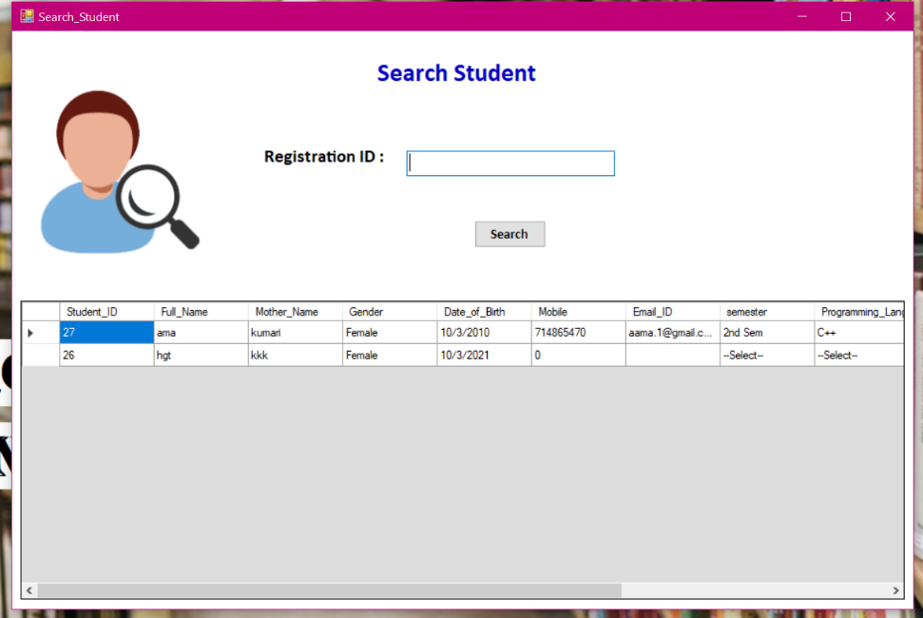

**Code: -**

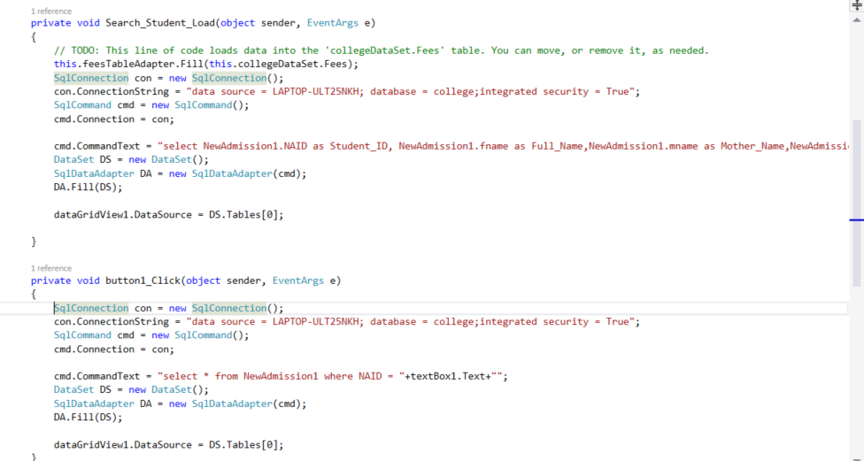

**Search Individual Student details: -**

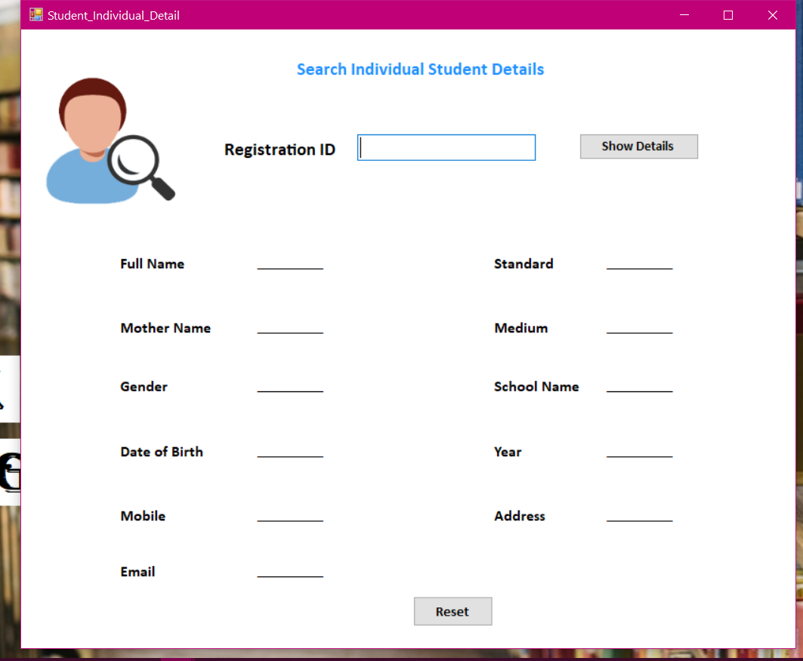

**Code: -**

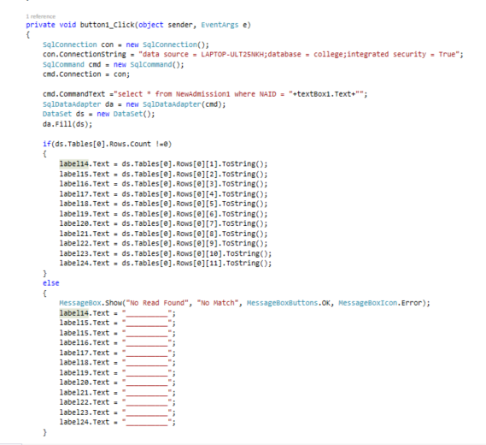

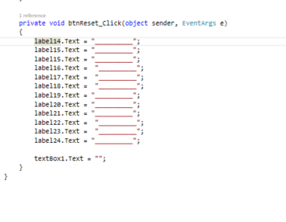

**Addteachers: -**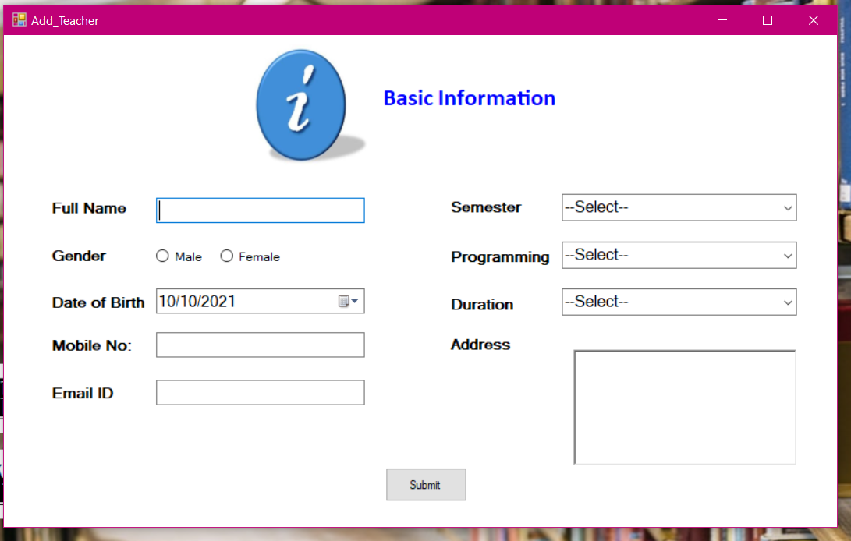

**Code: -**

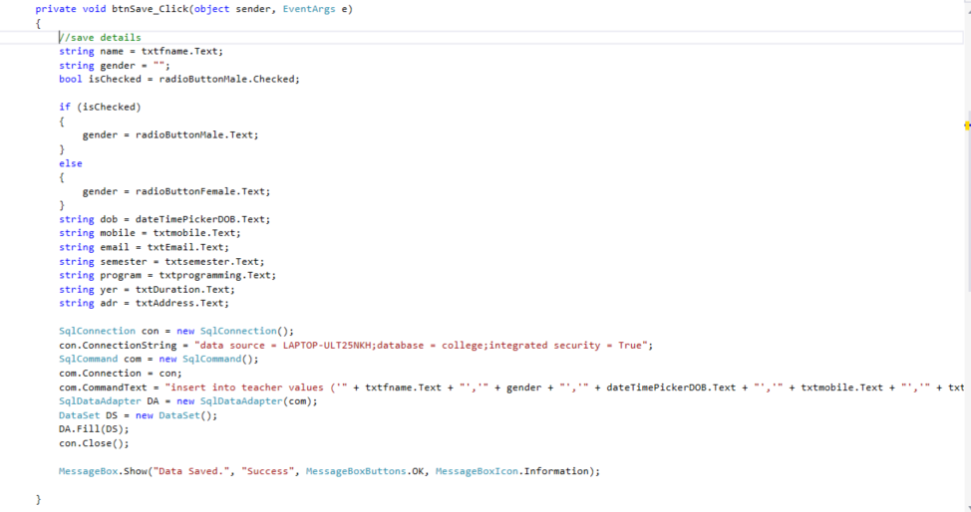

**Search teacher: -**

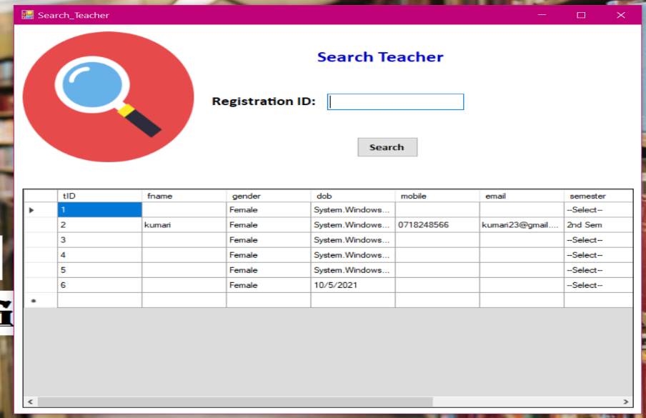

**Code: -**

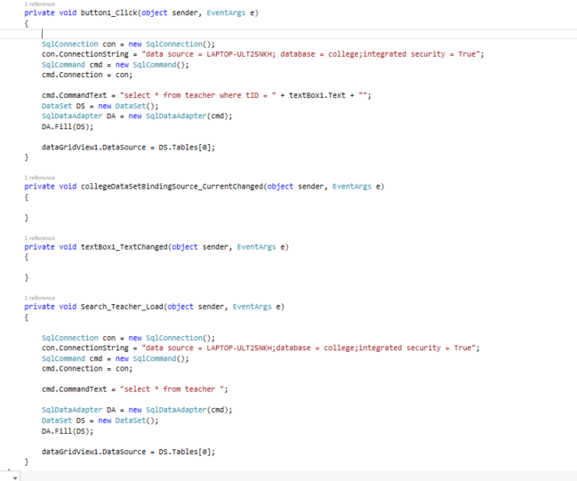

**Remove students: -**

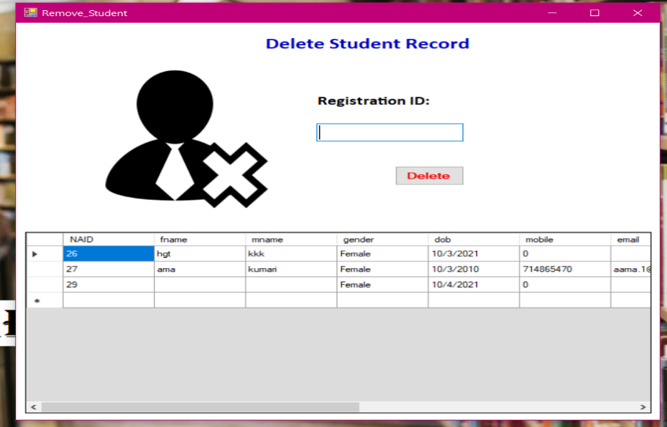

**Code: -**

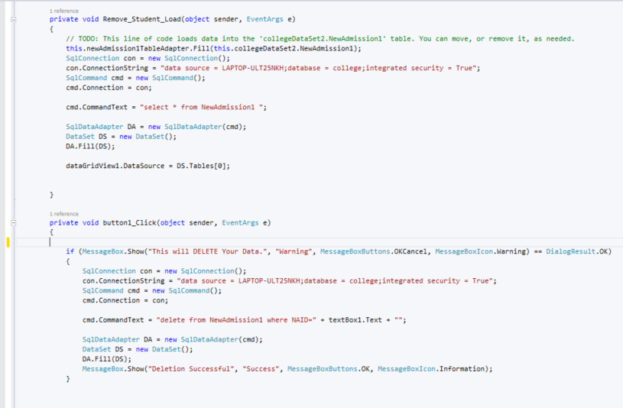

**Dashboard : -**

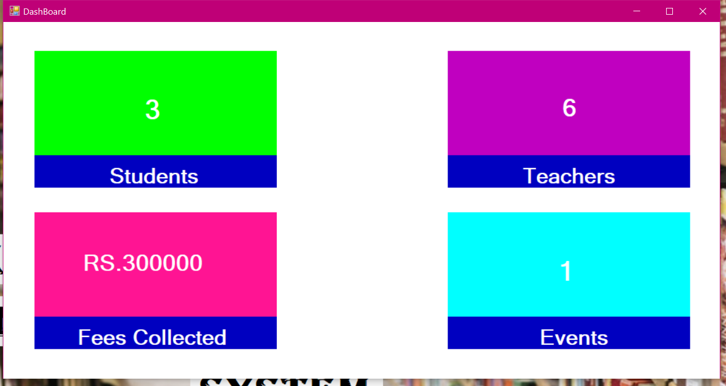

**Code: -**

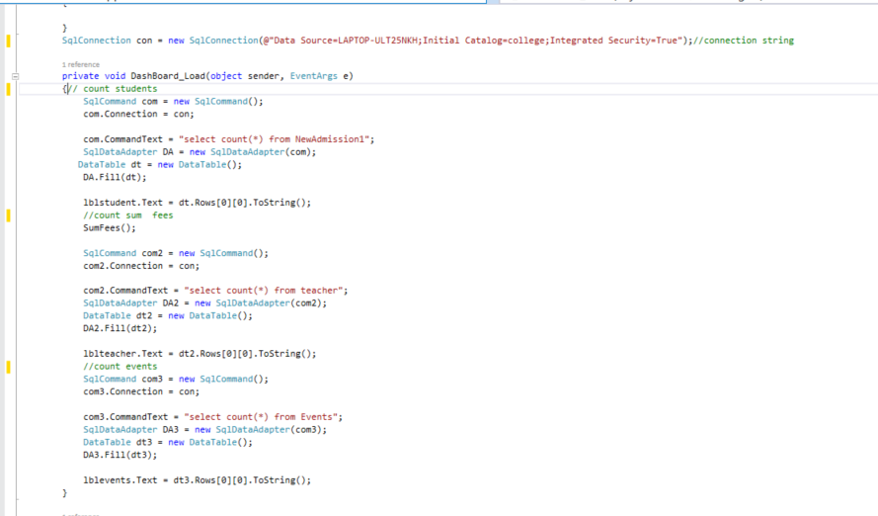

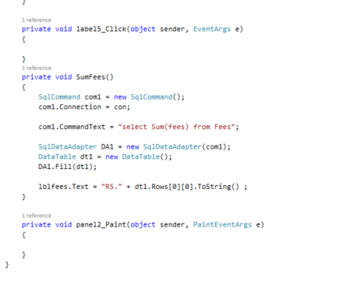

**About us : -**

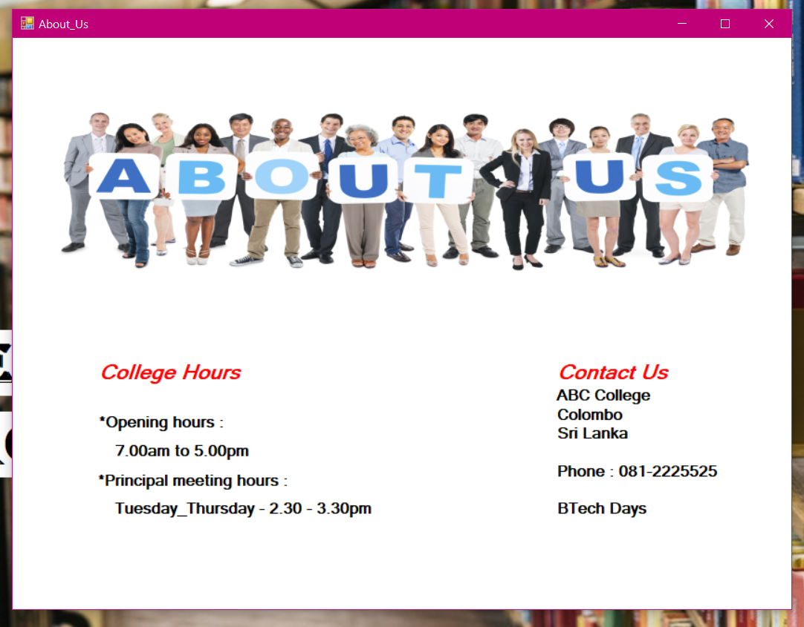

**Events: -**

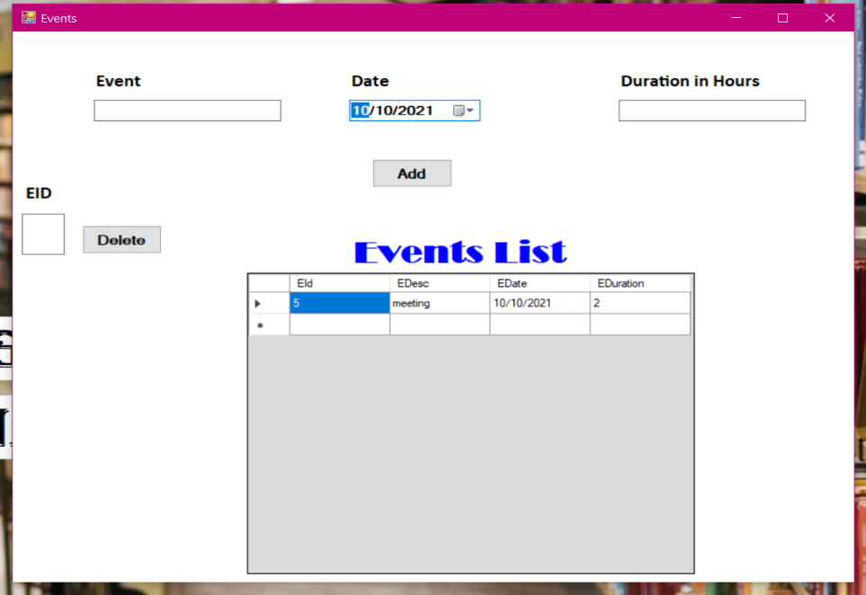

**Code: -**

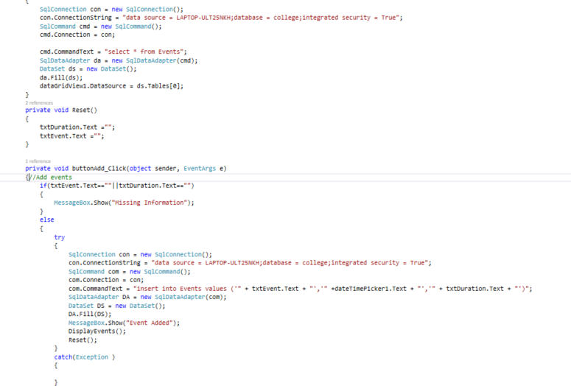

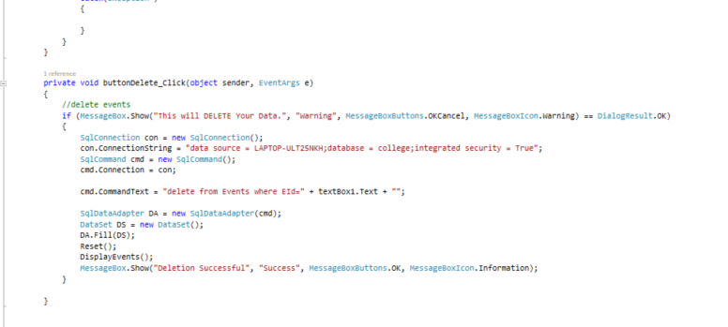

## 4.2 Database & Table data

**Student: -**

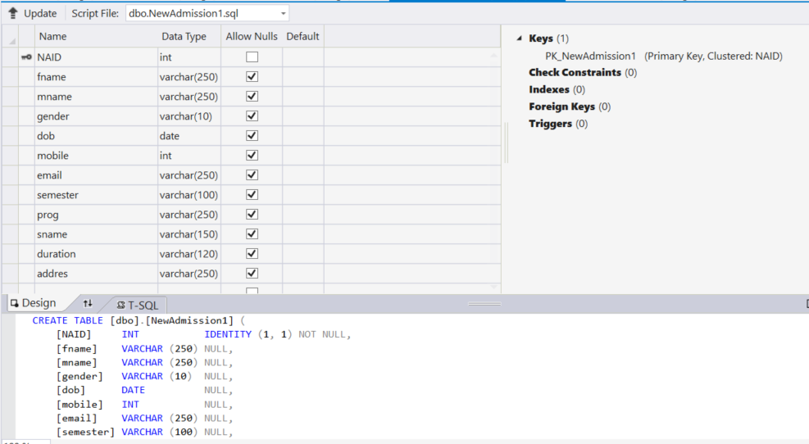

**Teacher: -**

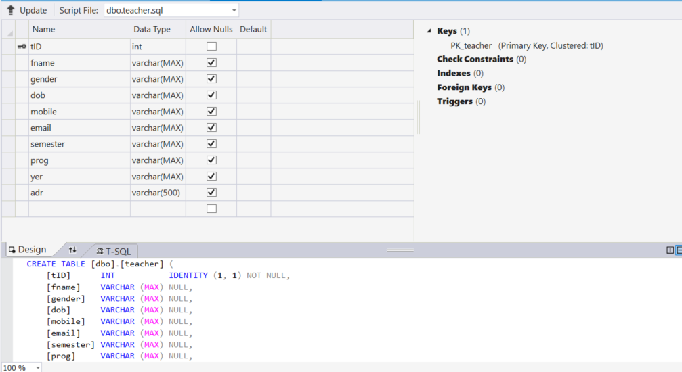

**Fees: -**

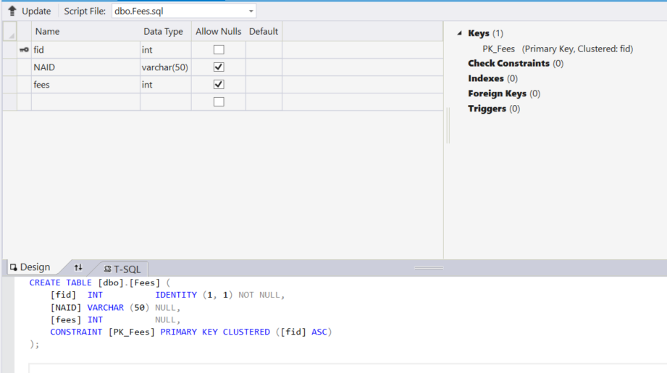

**Events: -**

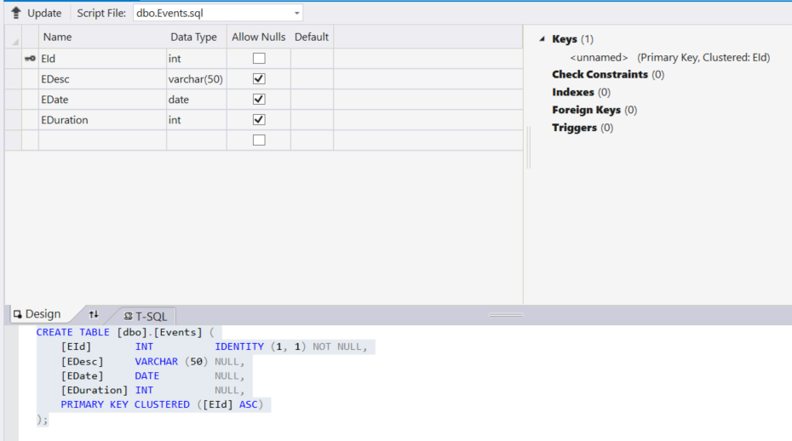

# Chapter 5 – Evaluation

## 5.1 Testing Techniques

**User Testing**

The initial training classes for users are held, and training materials are delivered at the classes. Some help desk personnel should attend the initial user training class. More training classes can be scheduled later, as new personnel start using the application. Training is done on the user acceptance test system, accessing the test database or a special training database.

**Black box testing**

Black box testing treats the software as a "black box," without any knowledge of internal implementation. Black box testing methods include: equivalence partitioning, boundary value analysis, all-pairs testing, fuzz testing, model-based testing, traceability matrix, exploratory testing and specification-based testing.

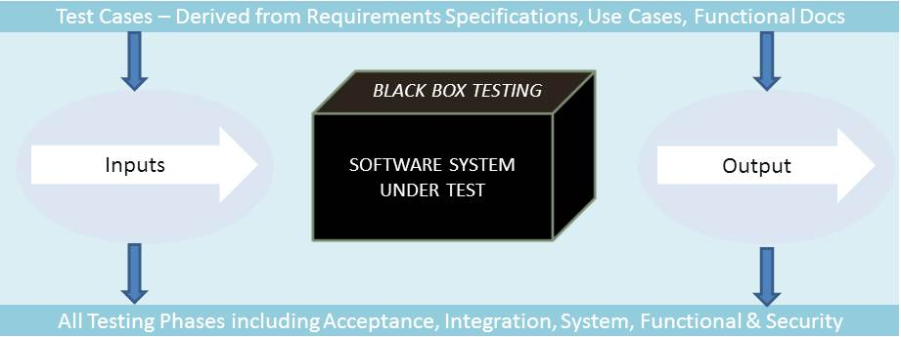

**White box testing**

White box testing, by contrast to black box testing, is when the tester has access to the internal data structures and algorithms (and the code that implement these).White box testing methods can also be used to evaluate the completeness of a test suite that was created with black box testing methods. This allows the software team to examine parts of a system that are rarely tested and ensures that the most important function points have been tested.

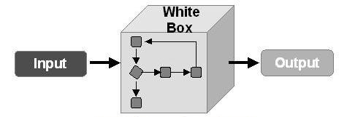

**System testing**

System Testing (ST) is a black box testing technique performed to evaluate the complete system the system's compliance against specified requirements. In System testing, the functionalities of the system are tested from an end-to-end perspective.

System Testing is usually carried out by a team that is independent of the development team in order to measure the quality of the system unbiased. It includes both functional and Non-Functional testing.

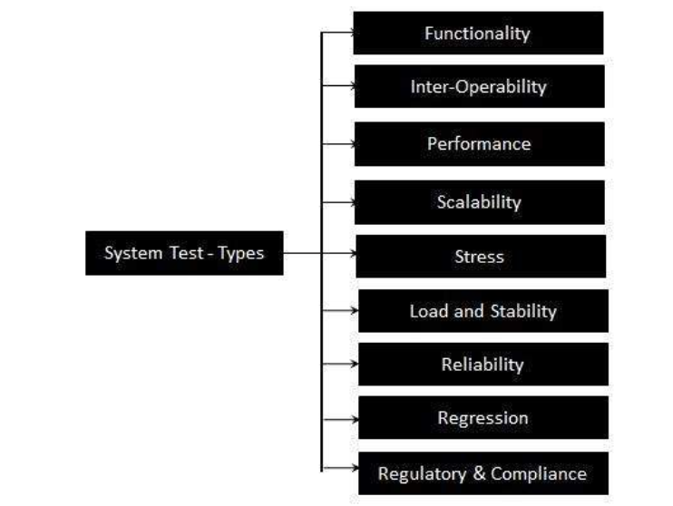

|  |  |  |  |  |
| --- | --- | --- | --- | --- |
| No | Test Case | Requirements | Expected  output | Real output |
| 1 | Admin/user login | Username or password incorrect. | Display  "Invalid User Name or Password" |  |
| 2 | Student registration | Notify student data saved. and remember registration ID number | Display  "Data Saved. Remember the Registration ID" |  |
| 3 | Semester update | Warning update | Display  "Semester Update Warning ! " |  |
| Notify when data update | Display  “Upgrade Successful",  "Success" |  |
| 4 | Remove student | Warning remove student | Display  "This will DELETE Your Data." |  |
| Notify when remove details successfully | Display  "Deletion Successful" |  |
| 5 | Pay fees | Notify when the pay fee successfully | Display  "Fees Submission Successful.", "Success" |  |
| 6 | Exit system | Notify logout | Display  "Are You Sure ? This will Delete Your UNSAVED Data " |  |

# Conclusion:

The project entitled as **College Management System** is the system that deals with the issues related to a particular institution.

* + This project is successfully implemented with all the features mentioned in system requirements specification.
  + The application provides appropriate information to users according to the chosen service.
  + The project is designed keeping in view the day to day problems faced by a college.
  + Deployment of our application will certainly help the college to reduce unnecessary wastage of time in personally going to each department for some information.

Awareness and right information about any college is essential for both the development of student as well as faculty. So this serves the right purpose in achieving the desired requirements of both the communities.

# References

1. R.S. Pressman, Software Engineering: A Practitioner’s Approach, McGraw-Hill, Ed 7, 2010.
2. P. Jalote, an Integrated Approach to Software Engineering, Narosa Publishing House, Edition 3, 2011.
3. <https://en.wikipedia.org/>
4. <https://www.google.co.in/>
5. <https://creately.com/>
6. [www.slideshare.net](http://www.slideshare.net)
7. [www.stackoverflow.com](http://www.stackoverflow.com)
8. [www.w3school.com](http://www.w3school.com)
9. [www.plularsight.com](http://www.plularsight.com)

